|  |
| --- |
| Intended for  UFMIT  Document type  Installation guide  Date  September, 2015 |
| WebLogic 12.1.3.0  Installation guide |

**MAJOR RELEASE REVISION-**

|  |  |
| --- | --- |
| Revision | 0.2 |
| Date | 2015-09-25 |
| Made by | Kiran Sankpal |
| Checked by |  |
| Approved by |  |
| Description | WebLogic 12.1.3.0 installation guide |
|  |  |
|  |  |

**SUB RELEASE REVISION**

|  |  |  |  |
| --- | --- | --- | --- |
| Revision | Date | Made by | Description |
| 0.2 | 2015-09-25 | Kiran Sankpal | Document version 0.2 created |

|  |
| --- |
| Contents |

1. Introduction and pre-conditions 1

1.1 Typography 1

1.2 Skills 1

2. Prerequisites 2

2.1 Environmental document 2

2.2 Software / Users 2

2.3 GUI ability on Linux, a prerequisite for implementing 2

3. WebLogic installation 4

3.1 Preparing WebLogic installation 4

3.2 Installing WebLogic 4

Introduction and pre-conditions

## Typography

In a number of places in this document there are highlighted sections. There are three different forms of these marked with a unique colour. They are used as follows:

|  |
| --- |
| Light grey: Marks commands issued on OS command line |

|  |
| --- |
| Light blue: Marks commands issued in SQLPlus |

|  |
| --- |
| Light yellow: Marks text in a file |

Turquoise background indicates something to be entered, brackets for keystrokes like [ENTER]

Green background indicates something to be marked or clicked on.

Pink background indicates number #99 or information from the document with environmental information.

Example for showing actual username on Linux

|  |
| --- |
| [user@server ~]$ whoami  username  [user@server ~]$ |

Guidance to click on something goes under the Graphic, as shown example:

[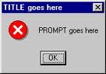](http://www.google.dk/imgres?imgurl=http://www.webreference.com/dhtml/column22/exMsgBox.gif&imgrefurl=http://sho3a3elamal.com/msgbox-yes-no&page=3&usg=__Qd6DZTUPeDiLMuIlMuyTRS9KypA=&h=119&w=171&sz=3&hl=da&start=207&zoom=1&tbnid=sWbLhsC2kgMpVM:&tbnh=95&tbnw=136&ei=l3VmTYDpM4KcOujesdAL&prev=/images?q=yes+no+prompt&hl=da&biw=1420&bih=700&tbs=isch:1&itbs=1&iact=rc&dur=1094&oei=SHVmTYjpBM_oOfCA-Y0L&page=8&ndsp=32&ved=1t:429,r:4,s:207&tx=88&ty=50)

Click OK to continue.

## Skills

This guide is intended for technical personnel with administration skills on Linux.

# Prerequisites

## Environmental document

It is necessary that the associated environmental information document is filled and ready to use.

## Software / Users

Java JDK has to be installed prior to WebLogic. The oracle user needs to be created with UID 500 and be a member of the DBA group GID 502.

## GUI ability on Linux, a prerequisite for implementing

Here xming is used to create GUI.

Installed:

* **Mremote version 1.5, with putty**
* **Xming-6-9-0-31-setup.exe**
* **Xming-fonts-7-5-0-25-setup.exe**

To enable the GUI, start putty.exe from "C: \ Program Files \ mRemote".

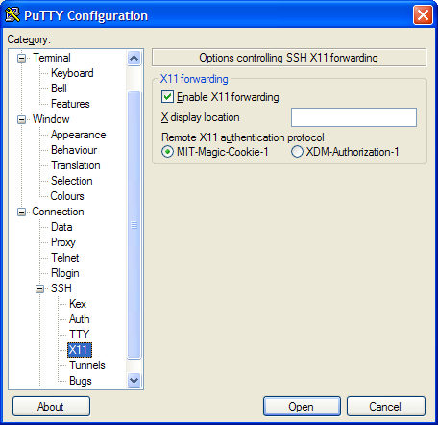

Under Connection / SSH / X11 mark flag for Enable X11 forwarding.

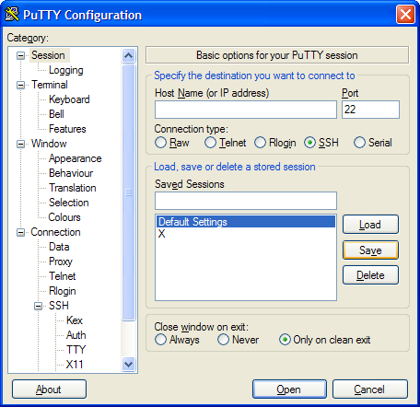

Under Session, mark the profile Default Settings and click Save.

# WebLogic installation

## Preparing WebLogic installation

As oracle, download WebLogic file to /tmp on Linux.

## Installing WebLogic

As oracle on Linux.

|  |
| --- |
| cd /tmp  #1 -jar fmw_12.1.3.0.0_wls.jar  Extracting 0%....................................................................................................100% |

A GUI wizard appears.

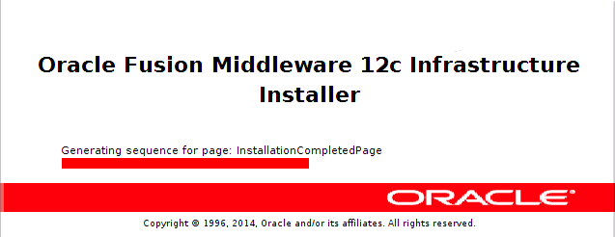

Wait...

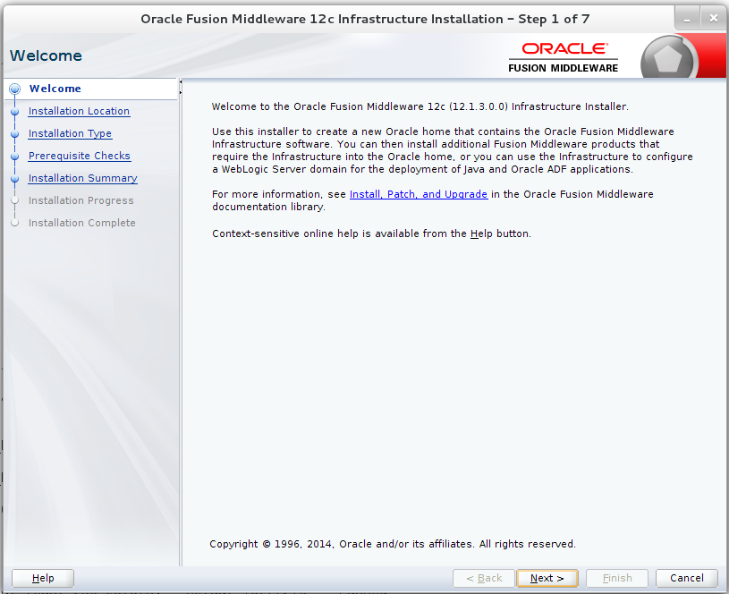

Click Next.

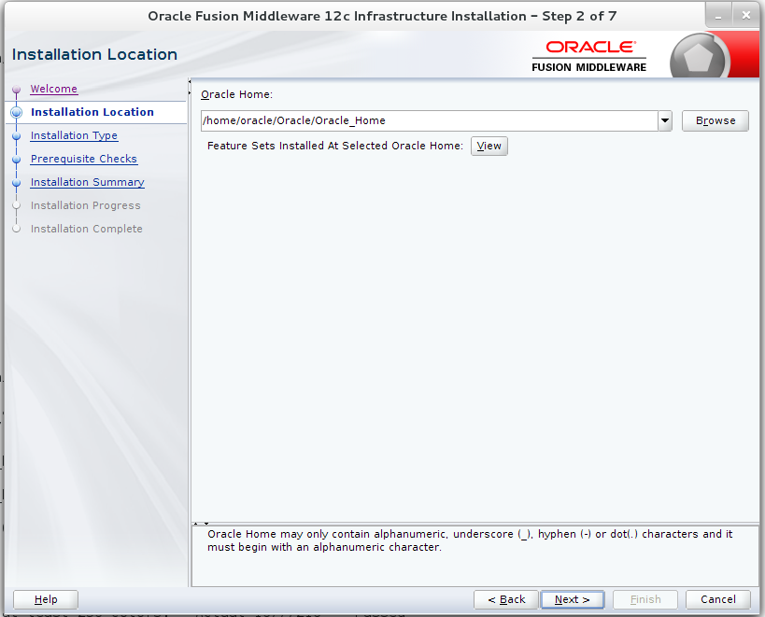

Enter Middleware Home Directory according to #2, click Next.

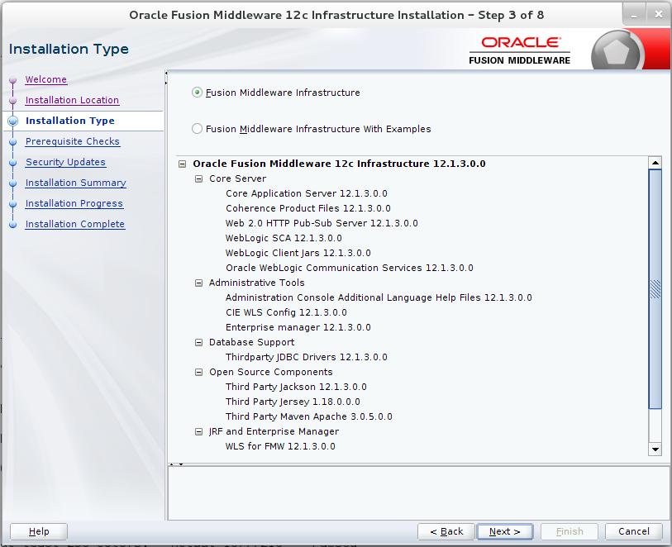

Select as per #3, Click Next.

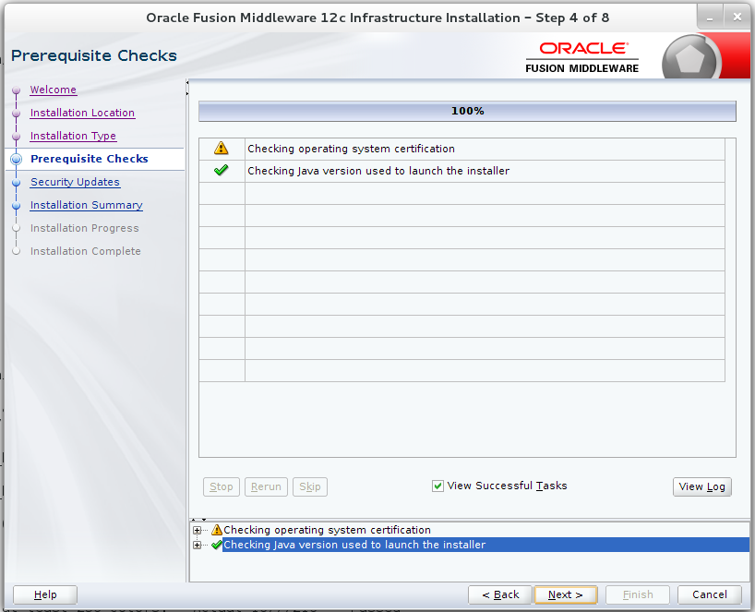

Click Next.

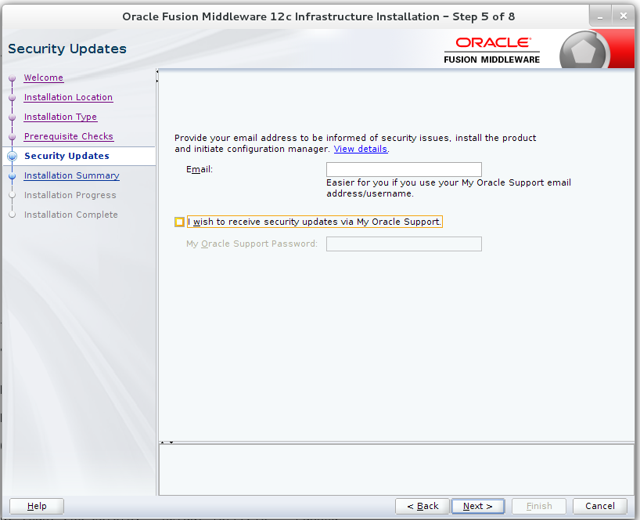

Choose according to #4, click Next.

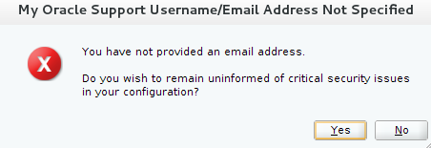

If you choose not to get security updates, you will get this info, just click Yes.

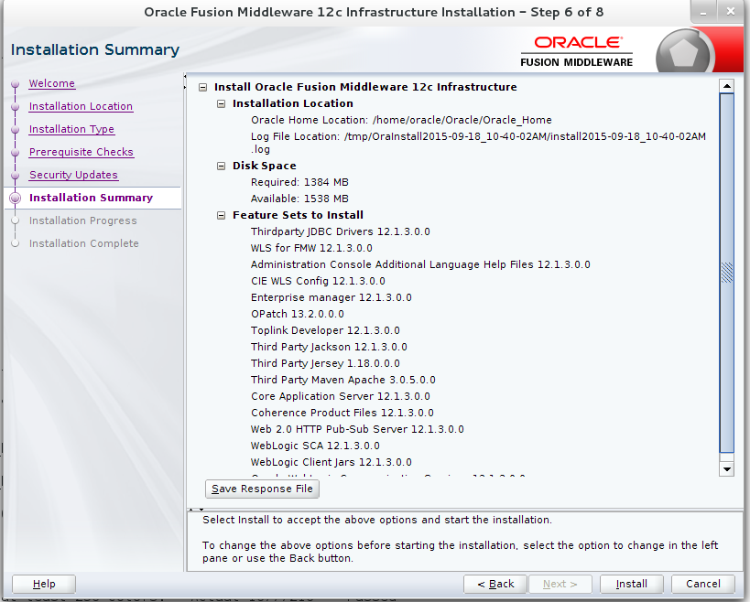

Click Install.

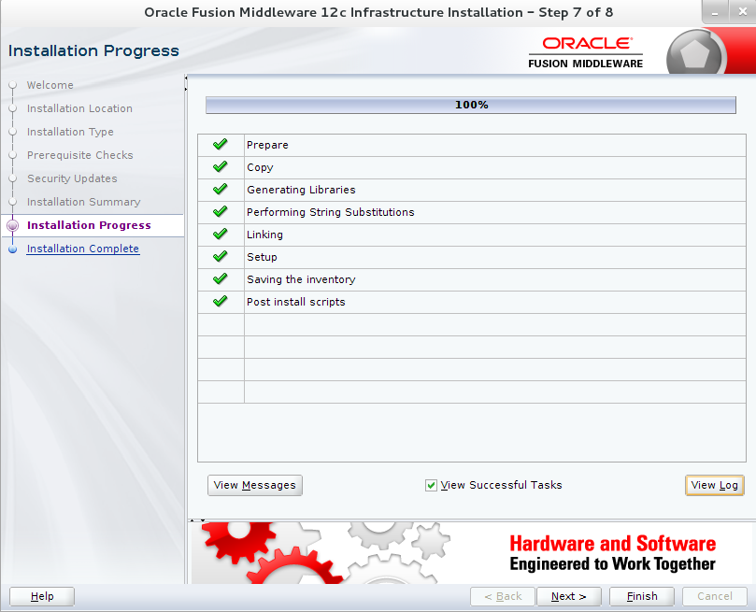

click Next.

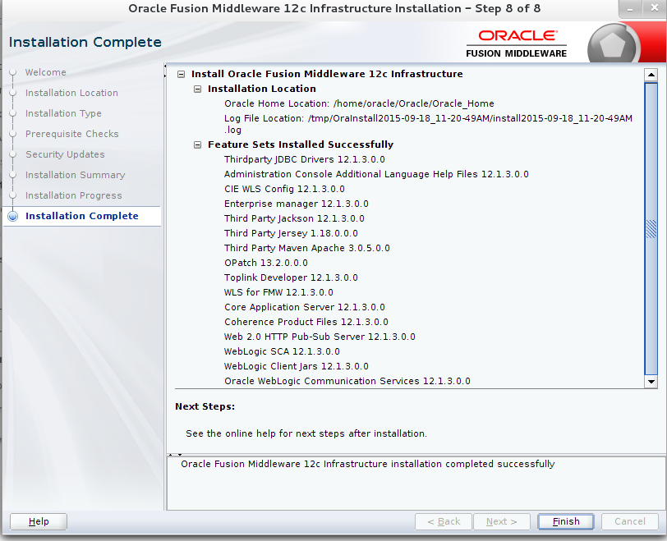

Click Finish.

Windows closed on X. Then back on Linux, finishing installation.

|  |
| --- |
| Mar 22, 2011 7:40:27 PM java.util.prefs.FileSystemPreferences$2 run  INFO: Created user preferences directory.  rm fmw_12.1.3.0.0_wls.jar  rm: remove regular file ` fmw_12.1.3.0.0_wls.jar’? y |